 Name: ……………………………………………………

|  |
| --- |
| **C.F. Mark** |
| /20 |

|  |  |
| --- | --- |
| **Total Mark** | **%** |
| /50 |  |

Mathematics Applications

Unit 2, Test 4, 2016 - Chapters 1-4, 13

**Calculator Free**

**25 min allowed**

**Question 1. [4 marks]**

Classify the following variables as:

1. categorical or numerical
2. nominal, ordinal, discrete or continuous
3. Eye colour b) House street numbers
   1. i.
   2. ii.
4. The number of people in a house. d) The length of time waiting in a queue.
   1. i.
   2. ii.

**Question 2. [3 marks]**

Scores are normally distributed with a mean of 28 and a standard deviation of 3.75. If the 75th percentile is 35, determine the interquartile range.

**Question 3. [3 Marks]**

The boxplots below show the test results from Class A and Class B. Each class had the same number of students and an identical test.

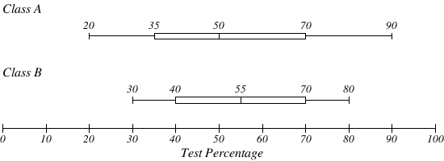

Compare the distributions shown in the boxplots above.

**Question 4. [1, 1, 3, 1 = 6 Marks]**

The number of runs scored in a cricket season is given in the table to the right.

1. Determine the modal class.

|  |  |
| --- | --- |
| **Cricket Runs Scored** | **Frequency** |
| $$0≤x<10$$ | 9 |
| $$10≤x<20$$ | 5 |
| $$20≤x<30$$ | 15 |
| $$30≤x<40$$ | 10 |
| $$40≤x<50$$ | 5 |
| $$50≤x<60$$ | 1 |

1. Calculate the median class.
2. Estimate the mean number of runs.

1. Explain why your answer to part (c) could only be an estimate.

**Question 5. [4 Marks]**

The maximum temperature recorded at Perth airport for each day of December in one particular year gave rise to the following data:

|  |  |  |  |  |  |
| --- | --- | --- | --- | --- | --- |
| Maximum Temperature (°C) | $$20→24$$ | $$25→29$$ | $$30→34$$ | $$35→39$$ | $$40→44$$ |
| Frequency (number of days) | $$3$$ | $$13$$ | $$8$$ | $$6$$ | $$1$$ |

Display this information as a frequency histogram below.

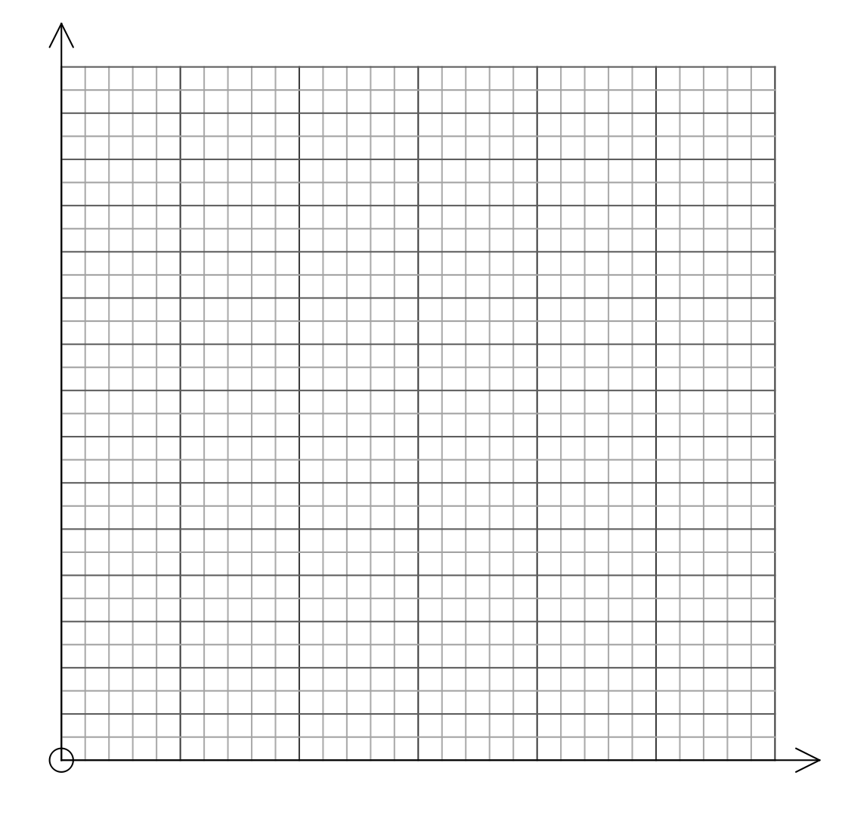

 Name: ……………………………………………………

|  |
| --- |
| **C.A. Mark** |
| / 30 |

Mathematics Applications

Unit 2, Test 4, 2016 - Chapters 1-4, 13

**Calculator Assumed**

**Calculators and 1 A4 page of notes allowed**

**35 minutes allowed**

**Question 6. [1, 2, 1, 2, 1, 2 = 9 Marks]**

The scores, out of 70, in a test are recorded in the group interval table below.

|  |  |  |  |  |  |  |
| --- | --- | --- | --- | --- | --- | --- |
| Test Score  (Out of 70) | $$10-19$$ | $$20-29$$ | $$30-39$$ | $$40-49$$ | $$50-59$$ | $$60-69$$ |
| Frequency | 1 | 3 | 4 | 9 | 11 | 3 |

1. How many tests were completed?
2. Calculate the
   1. Mean.
   2. Modal class interval.
   3. Median class interval.
   4. Range
   5. Standard Deviation

**Question 7. [2, 3 = 5 Marks]**

A weight of 9 gram sachets of saffron are normally distributed with a mean of 9.12 grams and a standard deviation of 0.15 grams.

1. What is the probability that a randomly selected sachet of saffron will weigh 9.2 grams or more?
2. What are the tenth and ninetieth percentiles for this distribution?

**Question 8. [5 Marks]**

Given the following data set and the statistical analysis, find the values of $a, b, c$ and $d$**.**

$$a 5 6 6 b c 12 13 14 d 17 24$$

Mean = 11.25

Range = 21

Median =11

Interquartile Range = 9.5

**Question 9. [2 Marks]**

If $Χ\sim N\left( 57.2, {12.4}^{2}\right)$ determine how many scores are no more than 30, given that there were 3472 scores.

**Question 10. [2, 2, 2 = 6 Marks]**

Julia recently completed her end of year examinations. Julia finds out from her languages teachers that the Italian exam had a mean of 62% and a standard deviation of 12 and the French exam had a mean of 48% and a standard deviation of 8.

1. Julia scored 66 in French. Convert this result to a Z-Score (Standardised Score).
2. Julia scored 71 in Italian. Convert this result to a Z-Score (Standardised Score).
3. In which subject did Julia attain the “better” result? Justify your answer.

**Question 11. [3 Marks]**

The 13 boys in a class gained a mean mark of 57% in a test, in which the class mean was 59%. If the class consisted of 20 students altogether find the mean achieved by the girls in the class. Give your answer correct to one decimal place.